 

INSTITUTE FOR ADVANCED COMPUTING AND SOFTWARE DEVELOPMENT AKURDI, PUNE

Documentation On

**“EDairy System”**

PG-DAC March 2023

*Submitted By:*

**Group No: 54**

Mr.Eknath A.Zaware Roll No. 229149

Mr.Akshay E.Gaikwad Roll No. 229126

**Mr. Rohit Puranik Mrs. Geete Darunte**

**Centre Coordinator Project Guide**

**Table of Contents**

1. Introduction 4

Document Purpose 4

Problem Statement 4

Product Scope 5

Aim & Objectives 5

1. Overall Description 6

Product Perspective 6

Benefits of Highway Help 7

User and Characteristics 7

Operating Environment 7

Design and Implementation Constraints 8

1. Requirements Specification 9

External Interface Requirements 9

Non-Functional Requirements 9

1. System Diagram 11

Activity Diagram 11

Data Flow Diagram 13

Class Diagram 15

Use Case Diagram 16

ER Diagram 16

1. Table Structure 17

users 17

admin 17

cart_products 17

carts 18

logins 18

order_products 18

order 18

products_details 18

products 19

transaction_details 19

user_products 19

1. Conclusion 20

Future Scope 20

1. References 20

**List of Figures**

Figure 1 User Activity Diagram ....................................................................................... 10

Figure2**.**SEQUENCE Diagram**---------------------------------------------------------------11**

Figure 3 Level 0 Data Flow Diagram ...............................................................................13

Figure 3 Level 1 Data Flow Diagram .................................................................................. 13

Figure 4 Class Diagram ....................................................................................................... 14

Figure 5 Use Case Diagram ................................................................................................. 15

Figure 6 ER Diagram ......................................................................................................... 16

# Introduction

The EDairy System project is a collaborative effort to create a secure online platform to provide the helpful fresh,pure Dairy Products to the users or customers at doorstep.The EDairy System project will allow product providers to list their products on an online application and to accept the payment directly from the users or customers. This will help the users/customers to get real taste of the products which are available on the application.

## Document Purpose

The EDairy System project is initiative to create an online platform for any user to consume the products which are available on the application. So that they will get real taste of the products which are available on the application.

The advancement in Information Technology and internet penetration has greatly enhanced various business processes and communication between society owners and their customers who are purchasing the flats. This EDairy is developed to provide the following products:

Enhance Business Processes:

To be able to use internet technology to project to the global world instead of limiting their products to their local domain alone, thus increase their return on investment (ROI).

Online Product Shopping:

A tool through which admin can register a products and provide many detailes to them. The admin also receives some set of functionalities which help in managing the products.

Online Product Shopping:

A tool through which customer can bye a products which ever he wants.

## Problem Statement

India has a unique pattern of production, processing and marketing/consumption of milk products incomparable to any large milk products producing country. India is the world’s largest milk producer and consumer of dairy products, consuming almost 100% of its own milk production. The Indian dairy sector is different from other dairy producing countries as emphasis is placed on both cattle and buffalo milk. In order to achieve greater profitability, quality standards need to be improved.

## Product Scope

The scope of EDairy System project would include designing and developing a digital platform that allows customers/users and product providers can track the actual location on the map and also we can extend this to the area which we want or for the whole country and world wide also.

This project traverses a lot of areas ranging from business concept and providing help to computing field, and required to perform several researches to be able to achieve the project objectives. The area covers include:

* Dairy industry: This includes study on how the daily Dairy processing work actually is being done, process involved and opportunity that exist for improvement.
* J2EE Technology used for the development of the application.
* Product provide­­­­­­­­ will be able to use the system effectively.
* Web-platform means that the system will be available for access 24/7 except when there is a temporary server issue which is expected to be minimal.

**Aims & Objectives**

Specific goals are: -

* To produce a web-based system that allow the admin to add Products Details and provide detailes to its role.
* To ease Product providers by providing different functionalities to it.
* To ease customers to order the essential dairy products from the site.

# Overall Description

## Product Perspective:

The EDairy System project is initiative to create an online platform for any user to consume the products which are available on the application. So that they will get real taste of the products which are available on the application.

* **PROPOSED SYSTEM**
  + Access Website (Admin, Customers):

User should be able to access web-application through either an application browser or similar product on the mobile phone or computer.

* + Registration (General Users):

Given that user and has accessed web-application, then should be able to register through the web-application. The user must provide first name, last name, email, contact number, username and password.

* + Admin Module :

Admin can login/logout. Admin can delete the Product providers, and users profile. Admin can display list of product providers, products and their locations by backend.

* + View Profile (Admin, General Users):

In which all can see their current profile status.

* + View Product Details (General Users):

General Users can see the products details by login to the web application. e.g., product name Product description and price etc.

* + User log-in (Admin and General Users):

Given that the user has registered, then the user should be able to login to the web-application. The login information will be stored on the database for future use.

* + Search products in product list:

Specific product can be viewed in the product list. Users and can search products by using product list.

* + Update products in product list:

Admin can update their products as well as add new products.Specific products can be viewed in the product list.

## Benefits of EDairy System:

* This online EDairy System is fully functional and flexible.
* It is very easy to use.
* This online EDairy System helps users to avail products which are available on this platform.
* It saves a lot of time,and important one safety.
* The application acts as an office that is open 24/7.
* It increases the efficiency of the management at offering quality products to the customers.
* It provides custom features development and support with the application.

**Users and Characteristic****s:**

*Admin*:

* + Admin can login to the system by backend.
  + Add a Products to system.
  + Add Product Details.
  + View Serivce Details.
  + Update Product Details.

*Customer:*

* + Customer can login to the system.
  + Customer can register.
  + Customer can update his/her details.
  + Customer can view available Products.
  + Customer can purchase Product.

## Operating Environment:

Server Side:

**Processor:** Intel® Xeon® processor 3500 series

**HDD:** Minimum 500GB Disk Space

**RAM:** Minimum 4GB **OS:** Windows 10, Linux 6 **Database:** Mysql

Client Side (minimum requirement):

**Processor:** Intel Dual Core

**HDD:** Minimum 80GB Disk Space

**RAM:** Minimum 1GB

**OS:** Windows 8 and above, Linux

## Design and Implementation Constraints:

* + The application will use Axios, JavaScript, HTML and css as main web technologies.
  + HTTP and FTP protocols are used as communication protocols. FTP is used to upload the web application in live domain and the client can access it via HTTP protocol.
  + Several types of validations make this web application a secured one.
  + Since EDairy System is a web-based application, internet connection must be established.
  + The EDairy System will be used on PCs and will function via internet or intranet in any web browser.
  1. **Specific Requirement**

## External Interface Requirements:

User Interfaces:

* + - All the users will see the same page when they enter in this website. This page shows a home page of our web site.
    - After being authenticated by correct username and password, user will be redirect to their corresponding profile where they can do various activities.
    - The user interface will be simple and consistence, using terminology commonly understood by intended users of the system. The system will have simple interface, consistence with standard interface, to eliminate need for user training of infrequent users.

Hardware Interfaces:

* + - No extra hardware interfaces are needed.
    - The system will use the standard hardware and data communication resources.
    - This includes, but not limited to, general network connection at the server/hosting site, network server and network management tools.

Application Interfaces:

**OS:** Windows 10, Linux

**Web Browser:**

The system is a web-based application; clients need a modern web browser such as Mozilla Firebox, Internet Explorer, Opera, and Chrome. The computer must have an Internet connection in order to be able to access the system.

Communications Interfaces:

* + - This system uses communication resources which includes but not limited to, HTTP protocol for communication with the web browser and web server and TCP/IP network protocol with HTTP protocol.
    - This application will communicate with the database that holds all the booking information. Users can contact with server side through HTTP protocol by means of a function that is called HTTP Services. This function allows the application to use the data retrieved by server to fulfil the request fired by the user.

**----System Designs---**

## 1. User Activity Diagram

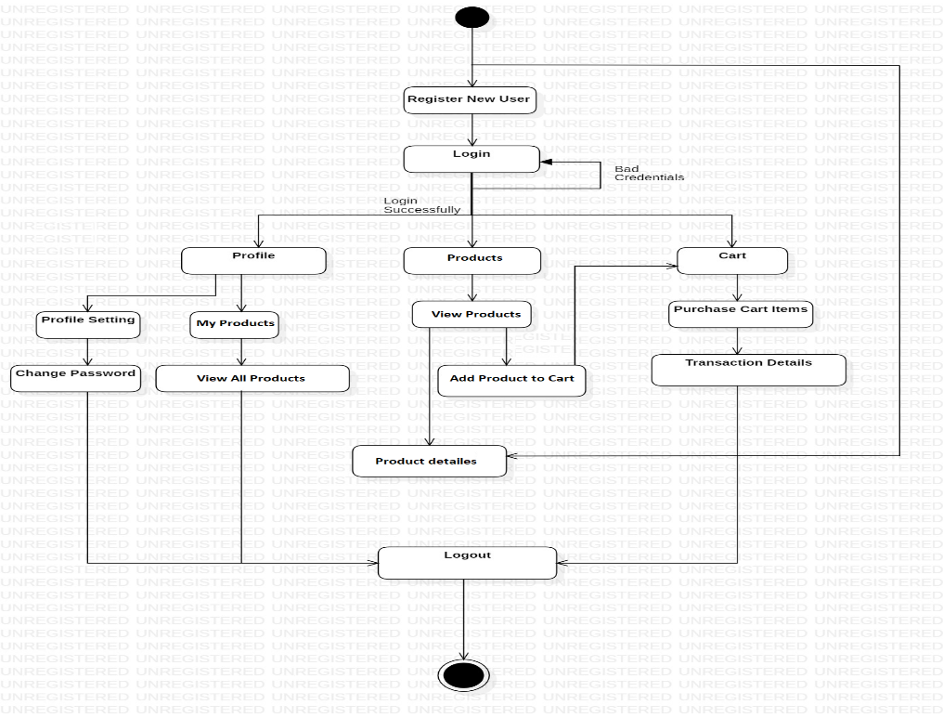

**Figure 1: User Activity Diagram**

**2.SEQUENCE Diagram-**

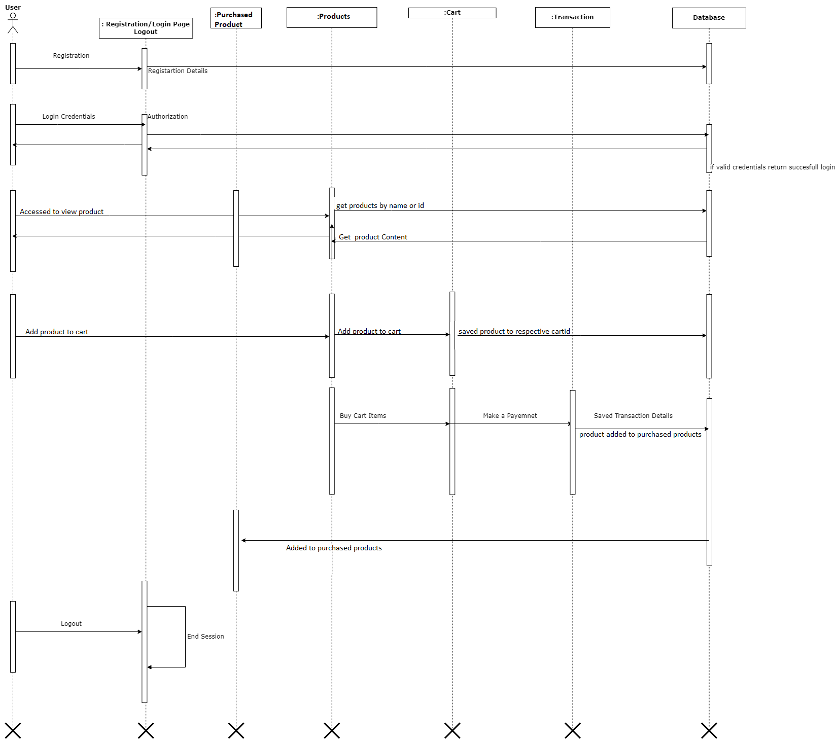

**SEQUENCE Diagram-2**

## 3.Data Flow Diagram

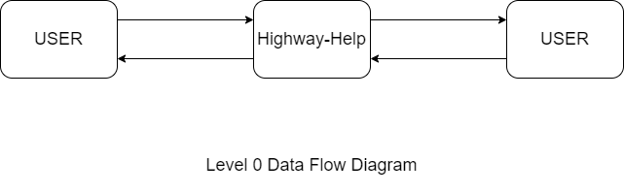

**Figure 4: Level 0 Data Flow Diagram**

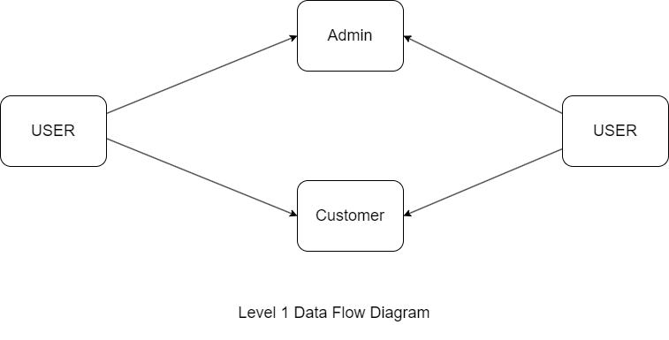

**Figure 5: Level 1 Data Flow Diagram**

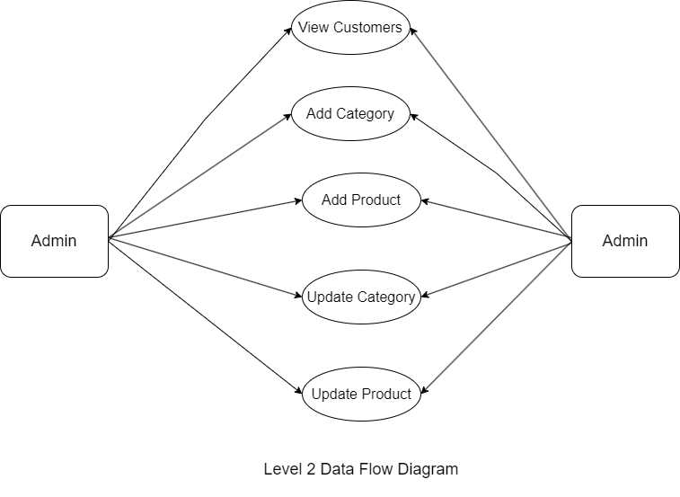

**Figure 6: Level 2 Data Flow Diagram for Admin**

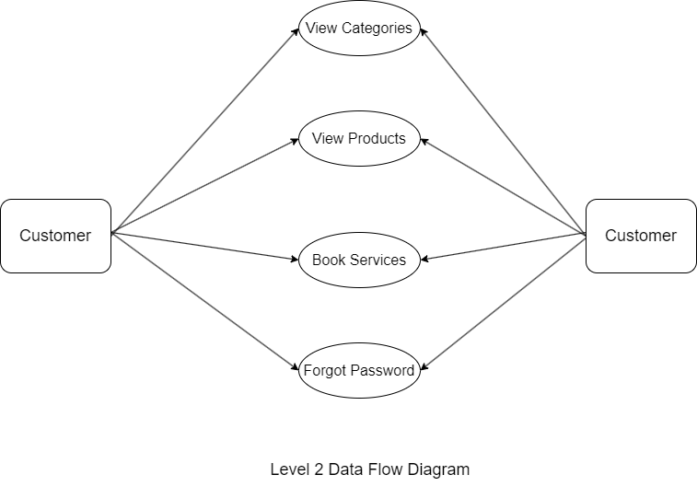

**Figure 7: Level 2 Data Flow Diagram for Customer**

4.Class Diagram

## 

**Figure 4: Class Diagram**

## 5.Use Case Diagram

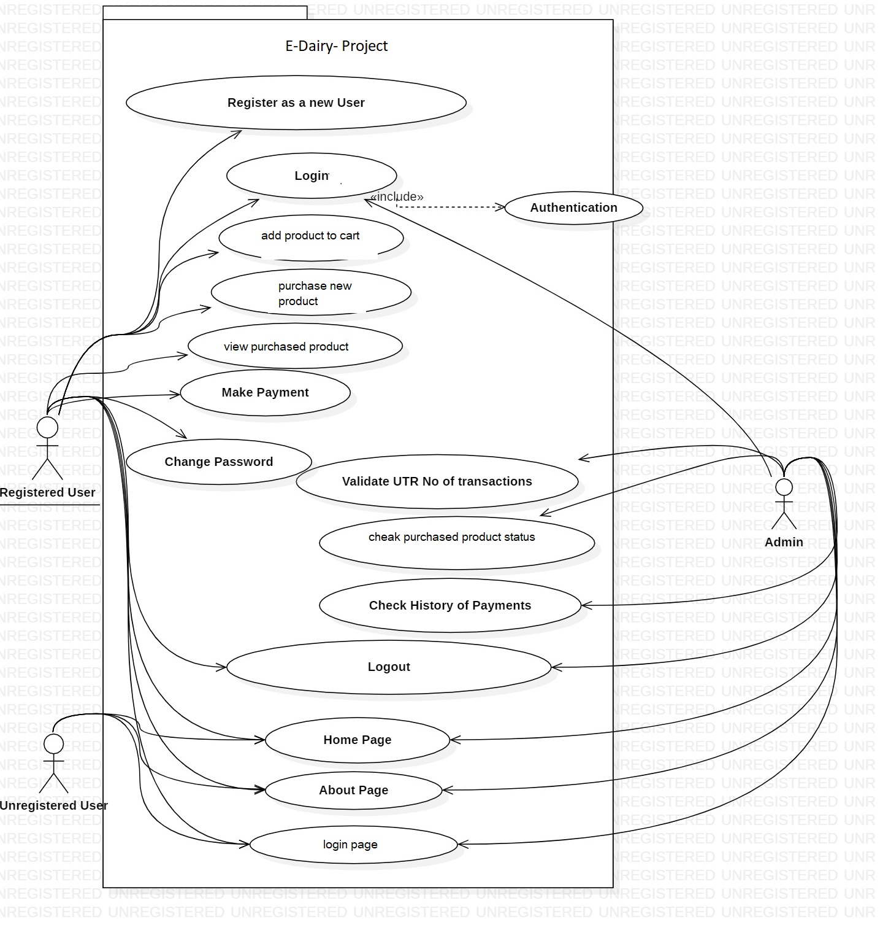

## 6. ER digram-

# Table Structure

**1.users:--**

|  |  |  |
| --- | --- | --- |
| **Name** | **Type** | **Extra** |
| id | bigint | Primary & Auto-increments |
| dob | date |  |
| email | varchar(30) |  |
| full_name | varchar(255) |  |
| gender | varchar(255) |  |
| phone | double |  |
| username_ | varchar(20) | Multiple |

**2.admins:**

|  |  |  |  |
| --- | --- | --- | --- |
|  | **Name** | **Type** | **Extra** |
| id | bigint(20) | Primary Key auto_inc |
| email | varchar(255) | Unique |
| fullname | varchar(20) |  |
| username | varchar(20) | Multi |
|
|

**3.Cart_products:**

|  |  |  |
| --- | --- | --- |
| **Name** | **Type** | **Extra** |
| cart_id | bigint |  |
| product_id | bigint(20) |  |

**4.Carts:-**

|  |  |  |
| --- | --- | --- |
| **Name** | **Type** | **Extra** |
| id | bigint | Primary & Auto-increment |
| cart_total | varchar(255) |  |
| no_items | int(11) |  |
| user_id | bigint(20) (20) |  |

**5.Logins:-**

|  |  |  |
| --- | --- | --- |
| **Name** | **Type** | **Extra** |
| username | varchar(20) | Primary |
| password | varchar(255) (6) |  |

**6.order_product:-**

|  |  |  |
| --- | --- | --- |
| **Name** | **Type** | **Extra** |
| order_id | bigint(20) |  |
| product_id | bigint(20) |  |

**7.orders:-**

|  |  |  |
| --- | --- | --- |
| **Name** | **Type** | **Extra** |
| id | bigint(20) | PRI, auto_increment |
| amount | double |  |
| date | date |  |
| user_id | bigint(20) |  |

**8.product_details:-**

|  |  |  |
| --- | --- | --- |
| **Name** | **Type** | **Extra** |
| id | bigint(20) | PRI, auto_increment |
| category_name | varchar(255) | UNI |
| product_id | bigint(20) |  |

9.**Products:-**

|  |  |  |
| --- | --- | --- |
| **Name** | **Type** | **Extra** |
| id | bigint(20) | PRI, auto_increment |
| description | varchar(255) |  |
| image_path | varchar(255) |  |
| in_stock | int(11) |  |
| price | double |  |
| product_name | varchar(255) |  |

10.**transaction_details:-**

|  |  |  |
| --- | --- | --- |
| **Name** | **Type** | **Extra** |
| id | bigint(20) | PRI, auto_increment |
| utrno | double |  |
| amount | double |  |
| date | date |  |
| price | double |  |
| order_id | bigint(20) |  |

11.**user_product:-**

|  |  |  |
| --- | --- | --- |
| **Name** | **Type** | **Extra** |
| user_id | bigint(20) |  |
| product_id | bigint(20) |  |

# Conclusion

The EDairy System project is initiative to create an online platform for any user to consume the products which are available on the application. So that they will get secure, gauranted and immediate product/help on time. And also these products will be secure and easily available to any user.

6. **Future Scope**

With continual investment in advanced infrastructure, manpower and systems to better our service and extend our geographical footprint, we are pacing rapidly towards the future. We are experimenting with new flavors and recipes, giving rise to innovative products that not only delight the taste buds but also elevate the health of our customers.We have tried our best to present this user–friendly website to all users.

**7.0 References**

1. <https://docs.oracle.com/en/java/>

[2] <https://docs.spring.io/spring-boot/docs/current/reference/htmlsingle/>

[3] <https://dev.mysql.com/doc/>

[4] <https://reactjs.org/>

[5] <https://www.fssai.gov.in/>